Heating Plate

**Introduction:**

A heating plate is a small, portable, and autonomous desktop appliance that has one or more electrical heating elements, and is used to heat containers with liquids, in a controlled way [1].

The methodology used for the development of the heating plate consists of the implementation of an ON-OFF controller, that is, a simple system which checks if the process variable is above or below a certain fixed point [2]. This implementation incorporates a feedback process, which allows to adjust the desired temperature of an electric stove and further adjust the precision given by the ON-OFF type controller. This implementation is carried out using two programmable digital thermostats that control the signal given by two astable oscillators, which control the work cycle of the electric stove. This implementation can also regulate the power used by the electric stove.

**Materials:**

1. Electric stove [5]

2. Submersible thermometer

3. XH-W1209 Digital Thermostat (2) [6]

4. NTC 10K 0.5% (2, included with each XH-W1209)

5. AC-DC 12V converter [7]

6. Oscillator H (materials and implementation below)

7. Oscillator C (materials and implementation below)

8. AC regulator (materials and implementation below)

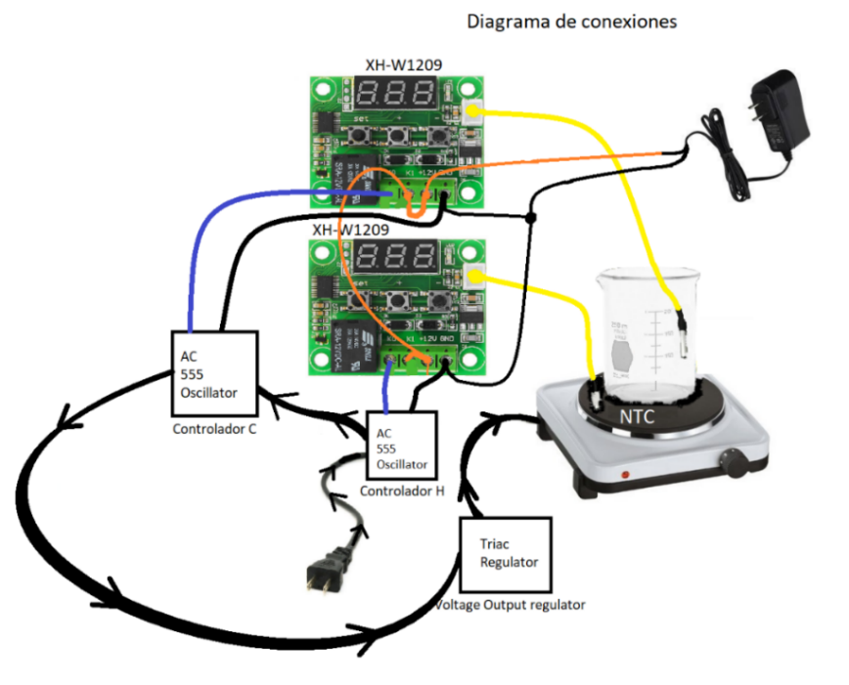

*Illustration 1: Connection diagram*

**Component Explanation:**

**LM555:**

The LM555 is a highly stable device for generating accurate time delays or oscillation. Additional terminals are provided for triggering or resetting if desired. In the time delay mode of operation, the time is precisely controlled by one external resistor and capacitor [3].

The LM555 timer used in this implementation is used in an astable configuration, which allows for a square signal at the output. This square signal allows for the operation of relays that control the current flow to the electric stove [4].

**XH-W1209:**

The implementation uses the XH-W1209 programmable digital thermostat which is a controller that allows a relay to be activated when it is below / above a desired temperature. The thermostat makes use of a 10K NTC thermistor (included with the thermostat) that allows to sense the current temperature, and thus, activate or deactivate its relay.

The thermostat works with a voltage of 12V, so it is recommended to use an AC-DC adapter of said voltage. When turned on, it shows the temperature currently sensed by the NTC. By pressing the SET button (left) the display flashes and shows the required temperature. Using the + (center) and - (right) buttons, the desired temperature is set.

Holding the SET button, the different settings of the digital thermostat appear. Using +, and - the user can go to the different settings, and by pressing SET they can be modified. When the desired setting is set, press SET again, and wait a couple of seconds to return to the current temperature. Here are all the thermostat settings:

**P0 H / C**

(Allows you to activate the relay when it is below the desired temperature / deactivate the relay when it is above the desired temperature)

**P1 Backlash 0.1 -15**

(It allows to adjust the trigger of the relay to the desired temperature + Backlash)

**P2 Upper limit 110 110**

(Sets the maximum measured temperature)

**P3 Lower limit -50 -50**

(Sets the minimum measured temperature)

**P4 Correction -7.0 ~ 7.0**

(Adjusts the resistance measured correction, adjust using the submersible thermometer)

**P5 Delay start time 0 - 10**

(Sets the relay trigger time in minutes)

**P6 High temperature alarm 0 - 110**

(Sets a maximum temperature, for the operation of the equipment, the equipment turns off when it reaches this limit, OFF default)

Pressing + and - for several seconds returns the values to their default values.

One of the XH-W1209 must be adjusted to P0 H, and another to P0 C. In this configuration, one triggers the relay when it is below the desired temperature, and the other triggers above the desired temperature. The correction values for P4 are adjusted using a submersible thermometer. The procedure for calibrating the values given by the thermostats is later explained.

This [link](https://www.youtube.com/watch?v=DBRI7ry0Ku8&ab_channel=Robojax) goes into more detail about the operation of the thermostat used for this implementation [https://www.youtube.com/watch?v=DBRI7ry0Ku8&ab_channel=Robojax]

**Oscillator H development:**

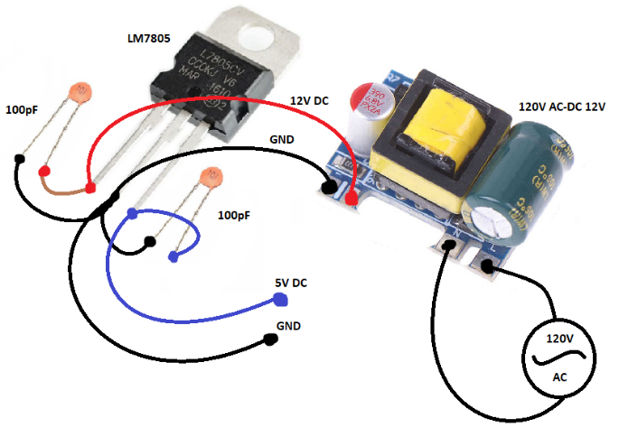Oscillator H is implemented using a NE555 timer in astable configuration. This controller oversees regulating the flow of current to the electric stove using relays, which oscillate and allow the stove to be energized for a time T, which is defined by the timer’s duty cycle. It should be taken into account that, in this case, the controller works with the inverse of the duty cycle. That is, for values that provide a 70% duty cycle, a 30% duty cycle will be used for the stove’s current flow. In the same way, it must be taken into account that the operating voltage of the oscillator H is 5V; thus, the circuit requires an LM7805 regulator for its operation. Below, you can see both the materials for the development of the oscillator H, as well as the connections to obtain the 5V from the 12V AC-DC adapter:

Materials:

* NE555
* 2x Cap. 10nF
* Cap. 270uF
* Cap. 1uF
* Trimmer 10kOhm
* Trimmer 50kOhm*
* 2X 5V Relay
* LM7805

Illustration 2: 5V regulator

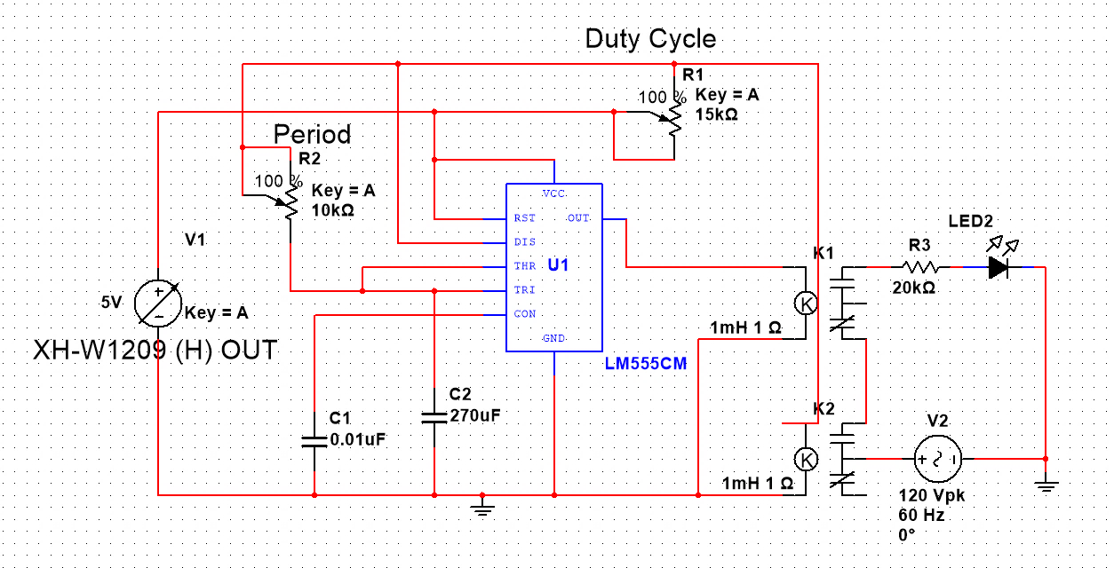

*Illustration 3: 555 H Oscillator (Annex 1)*

In this astable configuration of the NE555 timer, the controller features a frequency of 0.153Hz through the K1 relay, with a duty cycle of 71.43%, so the current flow only reaches the electric stove for 1.871s. It is not recommended to modify the value given by the 'Period' trimmer as it may affect the device life of the electric stove. By modifying the 'Duty Cycle' trimmer, the LOW time of the controller remains the same, thus effectively modifying the duty cycle of the controller, making the stove always receive 1,871s of current flow. Relay K2 is activated whenever digital thermostat H triggers the relay. In the illustration above, the hot plate is represented using a 20kOhm resistor, followed by an LED. This setting does not yet take feedback from the system into account. The feedback is provided by oscillator C.

However, a simple implementation without feedback can be done by only using oscillator H.

*As with the other devices, the trimmers can be adjusted to meet the values ​​in the images.

**Oscillator C development:**

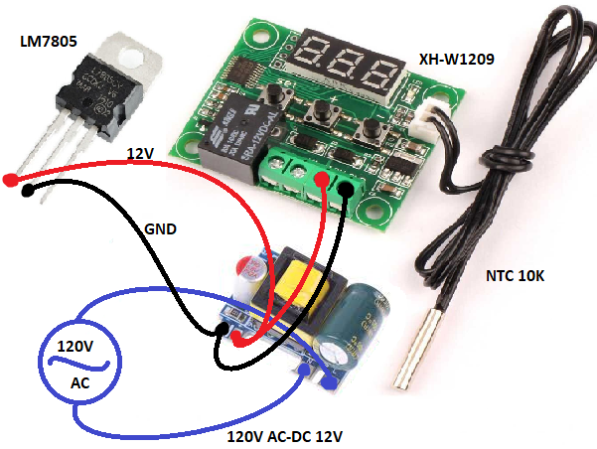The implementation of this oscillator is virtually the same as that of oscillator H. However, the values are taken so that the operating frequency is 0.534Hz, that is 1.871s, which is the LOW operating time of oscillator H. This implementation has a 54% duty cycle, which serves to halve the flow of current that reaches the electric stove.

Materials:

NE555

2x Cap. 10nF

Cap. 22uF

Cap. 1uF

2X Trimmer 50kOhm

5V Relay

Illustration 4: Adapter to thermostat and regulator

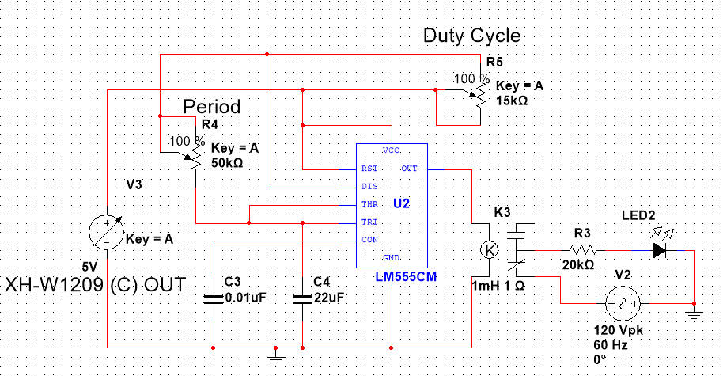

*Illustration 5: 555 C Oscillator (Annex 2)*

In case of modifying the Duty Cycle trimmer of oscillator H, the operating frequency must be adjusted with the Period trimmer on oscillator C, so that they maintain the same operating time. The duty cycle can vary as much as 10%.

The feedback of the system is given by the oscillator C, which modifies the duty cycle of the oscillator H once the temperature exceeds a desired limit. This flattens the heating curve given by oscillator H. In the illustration above, the heating plate is represented using a 20kOhm resistor, followed by an LED.

*Unlike the illustration, the trimmer values must be at 100%.

**AC Regulator:**

The voltage regulator implementation makes use of the BT136 Triac (an AC switch) and a potentiometer to regulate the output of the AC voltage. In this implementation, while having the potentiometer at 100% of its value, it is observed that all the current passes to the electric stove. By having the potentiometer at a value of 75%, a 50% decrease in the output voltage is observed, and for a 50% value of the potentiometer, a 100% decrease in the output voltage is observed. The behavior of the regulator can be observed in the following formula:

It should be taken into account that the AC regulator can be placed before or after the H and C controllers shown above since the connection between them is in series. Similarly, the implementation of the AC regulator is optional, and does not have a great impact on the final implementation. That is, this regulator serves to have greater precision in adjusting the temperatures of the final implementation of the heating plate.

Materials:

* Triac BT136
* Res. 1kOhm
* Res. 470 ohm
* Pot. 100kOhm

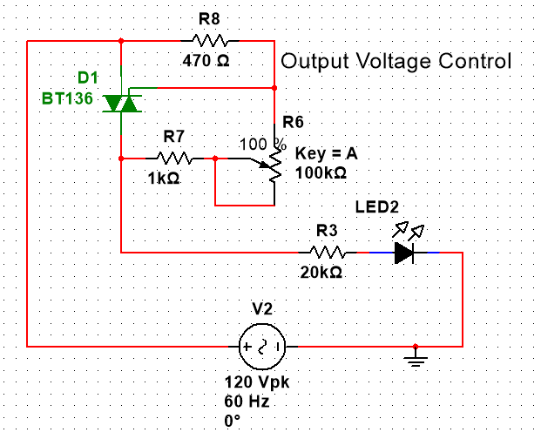

*Illustration 6: AC regulator (Annex 4)*

In the illustration above, the heating plate is represented using a 20kOhm resistor, followed by an LED.

Using all the devices, the following connection diagram is created for the development of the final device:

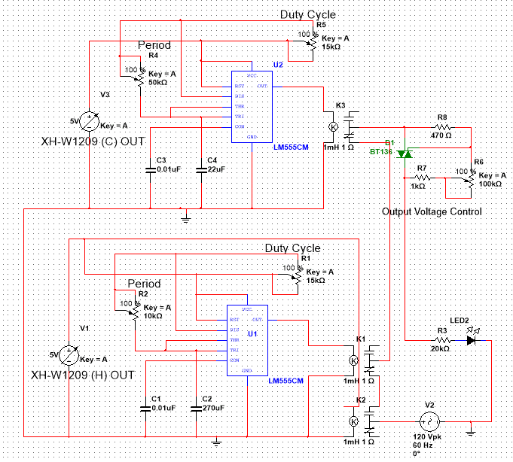**Final Device Diagram:**

Illustration 7: Diagram of the device (Annex 3)

*It should be noted that the PCB generated using the previous diagram was manufactured using the laboratories at Universidad de Los Andes.

Therefore, micrometer precision can be difficult to reproduce. It is recommended to take this into account before reproducing it, or generating a new PCB using the above diagram. The PCB can be seen below:

**Implementation:**

For the development of the implementation, it is suggested to incorporate the AC-DC 12V adapter to the same connection of the electric stove. This, to have a single AC connection and simplify the integration of the different devices. Similarly, the AC-DC 12V adapter can be connected separately, keeping the 12V and ground connections on the corresponding inputs of the digital thermostats.

**Controller Operation Test:**

Next, an implementation made in a soldering board (8b) is presented to carry out a simple operation test. It should be noted that the final implementation is done using a PCB (8a). This implementation has the function of showing, through the sounds generated by the relays, the operation of the controllers.

8.9cm

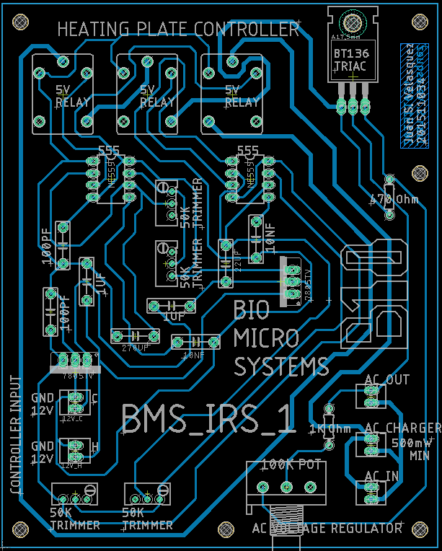

11.1cm

Illustration 8b: Soldering board diagram for link

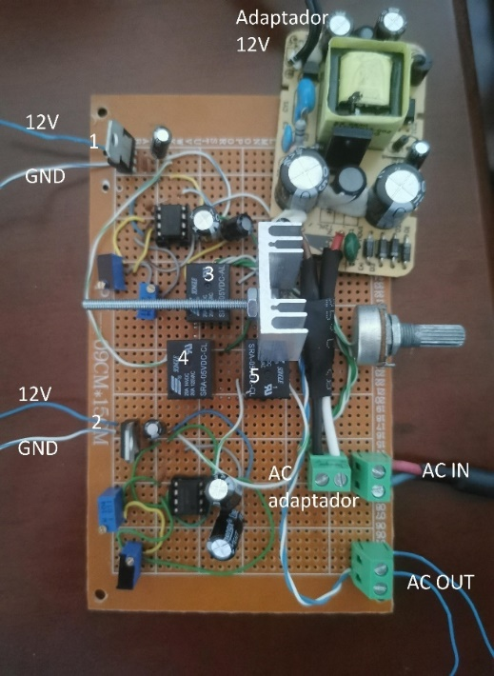

C Controller

H Controller

Illustration 8a: PCB diagram

The correct operation of the relays can be observed in the following [link](https://youtu.be/ANu1v0kD7Ro), in which the connection (1) is responsible for the operation of the relays (3) and (4). The first relay of the oscillator H (3) must be triggered when connecting the source, and the second relay (4) must be triggered every 1.8s-4.7s.

The connection (2) is responsible for the operation of the relay (5). Oscillator C relay must be triggered every 900ms-1s. The [link](https://youtu.be/ANu1v0kD7Ro) shows the operation of the device with both connections (1) and (2) connected.

[https://youtu.be/ANu1v0kD7Ro]

In the annexes, you can see a higher resolution image of the PCB generated for this implementation, as well as the finished product soldering the components onto the proposed PCB.

**Temperature Measurements:**

For the correct sensing of the temperature of the device, both 10K NTCs are connected to their respective XH-W1209. Below is a connection diagram for the digital thermostat used in the H and C controllers. The voltage is regulated using the 12V AC-DC adapter. It must be taken into account that the 12V voltage that feeds both the thermostat, and the oscillators must pass through the LM7805 5V regulator to energize the oscillators.

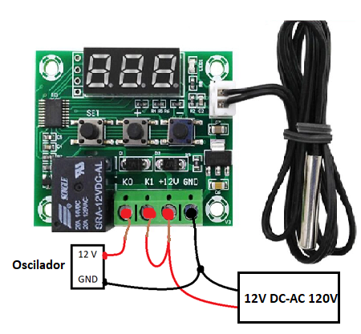

Illustration 9: Simplified connection diagram

To make the correct feedback through the XH-W1209 digital thermostats, the NTC 10K of the XH-W1209 H is placed on the electric stove, this to regulate the flow of current that reaches the stove. To improve thermal conduction, thermal paste can be used, which also improves the bond between the NTC and the stove. In the same way, the NTC 10K of the XH-W1209 C is placed inside the bath, to observe and regulate the circuit based on the bath’s temperature. Controller C, feeds back the current flow given by controller H.

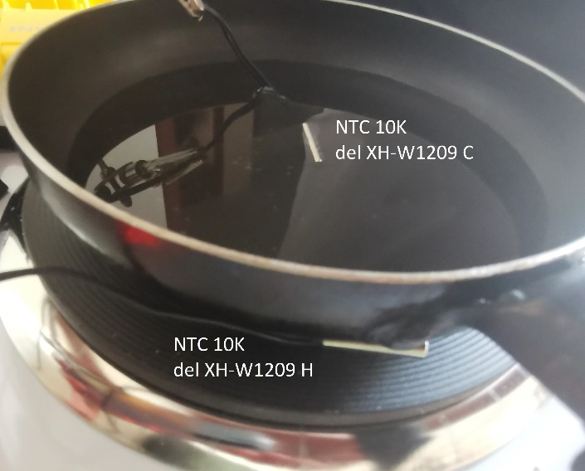

*Illustration 10: Positioning of the NTC 10K*

*The image above shows the thermal bath using a frying pan; however, glassware would provide the same results. For this implementation, a bath of approximately 100mL was used.

The setting of the temperature of the digital thermostat H is the value of the desired temperature, that is, the temperature that is desired for the thermostated bath. While the temperature setting of the digital thermostat C must be approximately 5°C lower than that of the XH-W1209 H for the controller to give the correct feedback. To start the calibration, the value of the voltage regulator is kept at 100%, that is, all the current flow reaches the stove.

**Calibration:**

It should be taken into account that the temperature of the electric stove can vary ± 1.2°C* since the temperature control system (taking into account the feedback) is based on an ON-OFF controller. Therefore, if higher precision is required, it is preferable to develop a PID-type controller.

*Value obtained from illustration 12, for a Duty Cycle of 75% at 35°C

For device calibration, turn on the device and adjust the temperatures of both XH-W1209 as stated above. Once the temperature of the electric stove stabilizes, the submersible thermometer is used to make a precise measurement of the bath temperature. It is recommended to place the desired temperature between 35°C and 40°C since commercial submersible thermometers have more accurate measurement values ​​for this temperature range. For this implementation, the thermometer used has an accuracy of ± 0.2°C in this range.

Using the P4 setting of the XH-W1209 thermostats, a correction of ± 7.0°C every 0.1°C can be made until the temperature given by the submersible thermometer is reached.

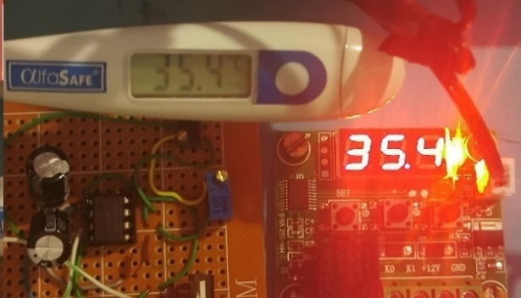

**Temperatura Baño**

*Illustration 11: Device Calibration*

If a temperature calibration or correction is required on the XH-W1209 H, an infrared thermometer should be used at the maximum suggested distance for correct measurements (usually 15cm), at an angle of 45°. This measurement is made by pointing the thermometer directly at the electric stove.

The measurement data of the thermometers used for the temperature correction of the electric stove are presented below:



*Illustration 12: Thermometer information*

Once the XH-W1209 thermostats have been calibrated for 35°C, the value of the Duty Cycle trimmer of oscillator H is adjusted to observe the behavior of the heat curve with different percentages of the duty cycle. This to observe a curve that presents a stable behavior. For this implementation, the value of the voltage regulator is kept at 100%. The different temperature curves for the duty cycle settings are shown below:

Illustration 13: Temperature curves at 35°C*



*The values of the percentages of the duty cycle are taken taking into account the operating times of the relays: [link Duty Cycle 60%](https://youtu.be/cjP7TYS4oLI) [https://youtu.be/cjP7TYS4oLI]; link [Duty Cycle 71%](https://youtu.be/mK7zi6v_CN8) [https://youtu.be/mK7zi6v_CN8]; link [Duty Cycle](https://youtu.be/RwB2JGHj_3M) 75% [https://youtu.be/RwB2JGHj_3M]

Using the trimmer setting for a 75% duty cycle, different temperature curves are taken to observe how the specific operating values for 35°C affect the other temperatures, and thus have a calibration curve for a range of higher temperatures. The curve with 75% duty cycle is used as it shows a more stable behavior. Similarly, using the temperature curve of 75% at 35°C, the calibration uncertainty of the device is generated (± 1.2°C, Standard Deviation = 0.588°C); which is later used for illustrations 14-16.

**Temperature curves:**

Data was taken for temperatures of 38°C, 44°C and 50°C. That is, the temperature set on the XH-W1209 H thermostat is 38°C, 44°C and 50°C respectively, while the temperature set on the XH-W1209 C is 33°C, 39°C, and 45°C respectively for system’s feedback. The data collection can be observed in the following images and in the following links:

[link curve 38°C](https://youtu.be/ohRhE2VJytI) [https://youtu.be/ohRhE2VJytI]; [link curve 44°C](https://youtu.be/vcO8OdUfcsQ) [https://youtu.be/vcO8OdUfcsQ]; [link curve 50°C](https://youtu.be/VLtTLCZcf1g) [https://youtu.be/VLtTLCZcf1g]



*Illustration 14: 38°C temperature curve of the electric stove*



*Illustration 15: 44°C temperature curve of the electric stove*



*Illustration 16: 50°C temperature curve of the electric stove*

**Linear Regression**

By getting an average temperature from minute 5 to the end of the temperature graph, the actual temperatures are obtained, based on the desired temperatures for the operating values for 35°C to create a temperature curve for the other values.

|  |  |  |  |
| --- | --- | --- | --- |
| Desired Temperature H controller | Feedback Temperature C controller | Actual Temperature | Standard Deviation |
| 35°C | 30°C | 35,089°C | 0.588°C |
| 38°C | 33°C | 37,809°C | 0.820°C |
| 44°C | 39°C | 41,528°C | 1.287°C |
| 50°C | 45°C | 46,389°C | 0.777°C |



*Illustration 17: Linear regression of temperature curves*

To verify the linear regression obtained with the calibration data, the equation obtained is used. Since for this implementation the maximum temperature is 50°C, this value is placed in the equation to obtain the temperature of the H and C controllers.



*Illustration 18: 55°C temperature curve of the electric stove*

When adjusting the controllers (controller H 55°C, controller C 50°C) with the equation obtained using the linear regression (2) of the temperature curves with the trimmer settings for 35°C, the desired temperature is effectively obtained. The temperature curve can be observed in the [55°C curve link](https://youtu.be/MEbPMuGhH5s) [https://youtu.be/MEbPMuGhH5s]. Similarly, uncertainties of ± 1.2°C corresponding to the 35°C calibration curve are placed.

Using the same procedure as the previous temperature curves for the average temperature, a value of 49,494°C is obtained, which is within the uncertainty values ​​obtained for the 35°C calibration curve. Using the data from minute 5 to the end of the measurement, a standard deviation of 1.33°C is also obtained.

Once the linear regression equation has been verified, an equation for the standard deviation with respect to the set temperature (35°C) and the current temperature of the system can be obtained. However, since the device is based on an ON-OFF controller, the standard deviation has a large degree of variance with respect to the expected values ​​(Annex 5).

**Comparison with commercial hot plates:**

Next, a comparison is made with other commercial hotplate models to observe the characteristics of the implemented hotplate:

|  |  |  |
| --- | --- | --- |
| Brand/Product | Uncertainty | Temperature Range |
| CorningPC-400D | ±5°C | 5°C – 550°C |
| SCILOGEX SCI550-Pro | ±1°C | 20°C – 550°C |
| ONILAB 340C | ±0.5°C | 20°C – 280°C |
| FOUR E’S MI0102003 | ±1°C | 20°C – 280°C |
|  | | |
| Device at 35°C* | ±1.2°C | N/A |
| Device at 55°C* | ±2.6°C | N/A |

*Device uncertainty for measured values

**Recommendations:**

For the first operation, it is recommended to place a temperature with a value 1°C above the desired one in the thermostats H and C. This is because the charging time of the controllers’ capacitors can impact the time response time, especially the response time of controller C (feedback process). Once it is observed that the temperature has begun to stabilize, the temperature value of the controllers can be modified to the expected values.

For a more precise measurement of both the temperature of the electric stove and the bath, it is recommended to set/glue the NTC 10K to the stove to avoid movements or oscillations caused by the environment.

**Observations:**

Compared to some of the commercial hotplates, the developed device manages to have comparable uncertainty values ​​for the measured temperatures. Thus, with proper calibration the device can be used in a laboratory environment.

Although the controllers have trimmers for both the duty cycle adjustment and the operating frequency, in this implementation only the duty cycle trimmers were used to adjust the temperature curve for 35°C. Using the other trimmers, it is possible to have a better temperature curve, which can have a better response to changes in the desired temperature of the oscillator H. Similarly, although the device has an AC voltage regulator at the output of oscillator C (feedback), for this implementation the value was not modified. That is, the voltage was maintained at 100% of the input value. By making modifications to this regulator, better temperature curves could be obtained that more closely match the desired temperatures.

It should be noted that all the temperature curves were made using a bath of approximately 100mL.

The measurements and temperature curves of this implementation were only performed for values ​​in the range of ambient temperature up to 50°C. For higher temperature implementation, it is recommended to perform the initial calibration at a temperature close to that desired for device operation.

**References:**

1. Wikimedia Foundation. (n.d.). Placa Calefactora. Wikipedia. https://es.wikipedia.org/wiki/Placa_calefactora#:~:text=Una%20placa%20calefactora%20es%20un,l%C3%ADquidos%2C%E2%80%8B%20de%20forma%20controlada.
2. dice:, A. N. I. B. A. L. D. I. A. Z., dice:, N., Dice:, L. F. O., dice:, J. C. V., & dice:, J. A. V. (2020, June 18). *Control ON/OFF o Todo/Nada*. instrumentación y Automatización Industrial. https://instrumentacionycontrol.net/control-on-off-o-todo-nada/.
3. TI. (2015, January). *LM555 Timer*. Texas Instruments. https://www.ti.com/lit/ds/symlink/lm555.pdf.
4. Gómez, E. (2021, May 6). *555 astable, ¿qué es? ¿Cómo configurar?* Rincón Ingenieril. https://www.rinconingenieril.es/555-astable/.

**Shopping Items Links:**

1. <https://articulo.mercadolibre.com.co/MCO-562121780-estufa-electrica-un-puesto-1000w-_JM?quantity=1&variation=55608897828>
2. <https://articulo.mercadolibre.com.co/MCO-454743554-termostato-digital-xh-w1209-_JM?quantity=1#position=1&type=item&tracking_id=00422020-dc94-4206-a93b-18d22b06d4a2>
3. <https://articulo.mercadolibre.com.co/MCO-469275794-fuente-adaptador-12v-1a-1000ma-arduino-ac-dc-110v-ac-power-_JM?quantity=1#position=4&type=item&tracking_id=4ba5fac1-2e1f-4a40-bf10-89d48b3461f4>

**Annexes:**

Controller H Duty Cycle 75%

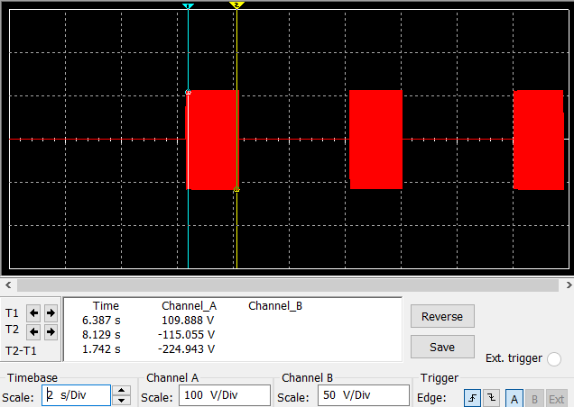

Controller C Duty Cycle 54%

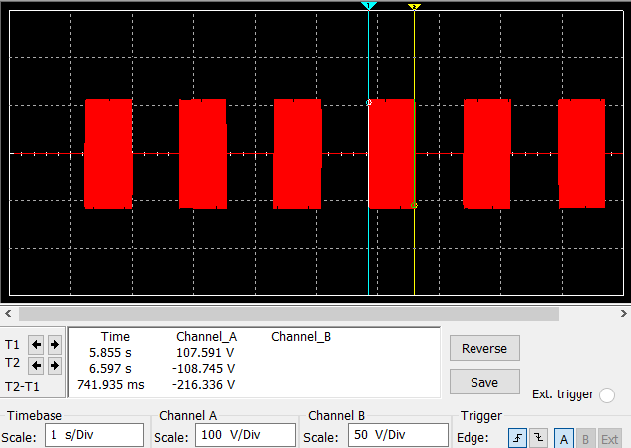

Controller H with Controller C

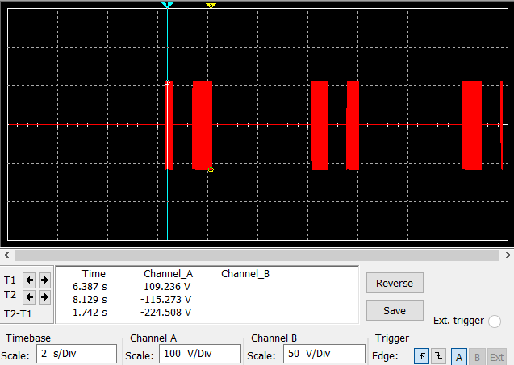

Voltage Regulator at 75%

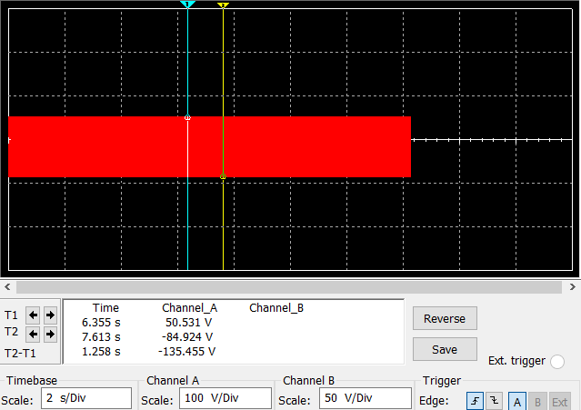

Standard Deviation Values



PCB Design



PCB Implementation

